Practical 6: Configuring a Zone-Based Policy Firewall (ZPF) Topology
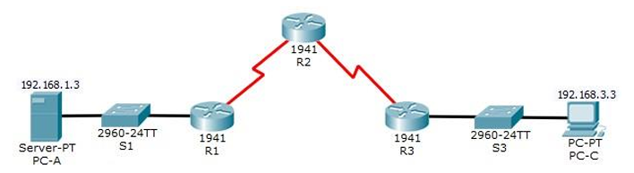
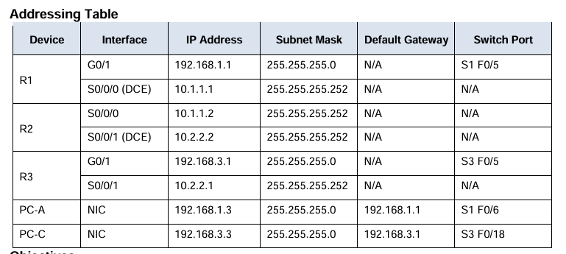

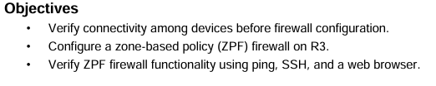
Routing:
Router 1:
Router(config)#hostname R1
R1(config)#Router rip
R1(config-router)#Version 2
R1(config-router)#Network 192.168.1.0
R1(config-router)#Network 10.1.1.0
Router 2:
Router(config)#hostname R2
R2(config)#Router rip
R2(config-router)#Version 2
R2(config-router)#Network 10.2.2.0
R2(config-router)#Network 10.1.1.0
Router 3:
Router(config)#hostname R3
R3(config)#Router rip
R3(config-router)#Version 2
R3(config-router)#Network 192.168.3.0
R3(config-router)#Network 10.2.2.0

SSH configuration on R2
R2(config)#ip domain-name ccnasecurity.com
R2(config)#username SSHadmin privilege 15 secret ciscosshpa55
R2(config)#line vty 0 4
R2(config-line)#login local
R2(config-line)#transport input ssh
R2(config-line)#crypto key generate rsa
The name for the keys will be: R2.ccnasecurity.com
Choose the size of the key modulus in the range of 360 to 2048 for your
General Purpose Keys. Choosing a key modulus greater than 512 may take
a few minutes.

How many bits in the modulus [512]: 1024

Part 1: Verify Basic Network Connectivity
Step 1: From the PC-A command prompt, ping PC-C at 192.168.3.3.
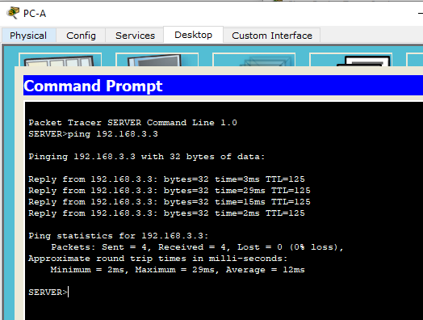
Step 2: Access R2 using SSH.
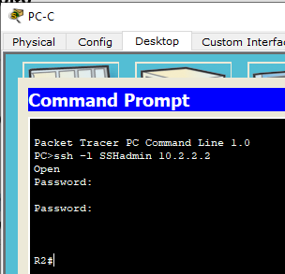
Step 3: From PC-C, open a web browser to the PC-A server.

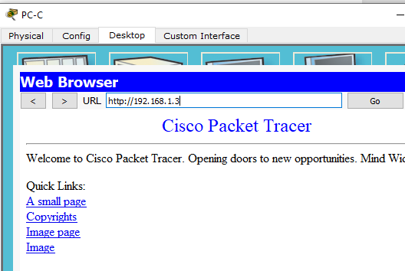

Part 2: Create the Firewall Zones on R3
Step 1: Enable the Security Technology package.
- On R3, issue the show version command to view the Technology Package license information.

R3#show version
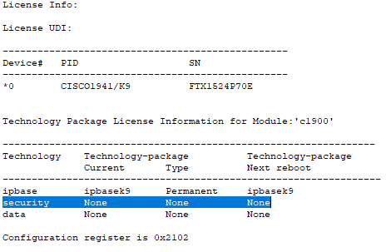
b. If the Security Technology package has not been enabled, use the following command to enable the package.
R3(config)#license boot module c1900 technology-package securityk9
c. Accept the end-user license agreement.
d. Save the running-config and reload the router to enable the security license.
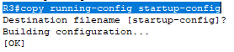
Press enter for destination filename
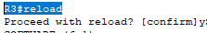 press y
e. Verify that the Security Technology package has been enabled by using the show version command.
R3#show version
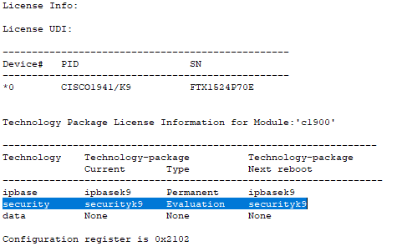
Step 2: Create an internal zone. Use the zone security command
R3(config)#zone security IN-ZONE
R3(config-sec-zone)#exit
Step 3: Create an external zone.
R3(config)#zone security OUT-ZONE
R3(config-sec-zone)#exit

Part 3: Identify Traffic Using a Class-Map
Step 1: Create an ACL that defines internal traffic.
R3(config)#access-list 101 permit ip 192.168.3.0 0.0.0.255 any
Step 2: Create a class map referencing the internal traffic ACL.
R3(config)# class-map type inspect match-all IN-NET-CLASS-MAP
R3(config-cmap)#match access-group 101
R3(config-cmap)#exit

Part 4: Specify Firewall Policies
Step 1: Create a policy map to determine what to do with matched traffic.
R3(config)# policy-map type inspect IN-2-OUT-PMAP

Step 2: Specify a class type of inspect and reference class map IN-NET-CLASS-MAP.
R3(config-pmap)# class type inspect IN-NET-CLASS-MAP

Step 3: Specify the action of inspect for this policy map.
R3(config-pmap-c)#inspect
R3(config-pmap-c)#exit
R3(config-pmap)#exit

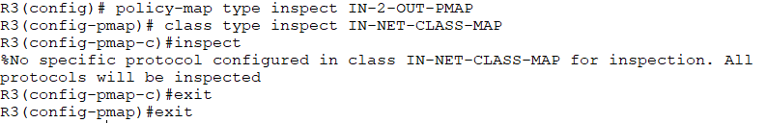

Part 5: Apply Firewall Policies
Step 1: Create a pair of zones.
R3(config)#zone-pair security IN-2-OUT-ZPAIR source IN-ZONE destination OUT-ZONE
Step 2: Specify the policy map for handling the traffic between the two zones.
R3(config-sec-zone-pair)#service-policy type inspect IN-2-OUT-PMAP
R3(config-sec-zone-pair)#exit
Step 3: Assign interfaces to the appropriate security zones.
R3(config)#interface g0/1
R3(config-if)#zone-member security IN-ZONE
R3(config-if)#exit
R3(config)#interface s0/0/1
R3(config-if)#zone-member security OUT-ZONE
R3(config-if)#exit
Step 4: Copy the running configuration to the startup configuration.
R3#copy running-config startup-config

Part 6: Test Firewall Functionality from IN-ZONE to OUT-ZONE
Step 1: From internal PC-C, ping the external PC-A server.
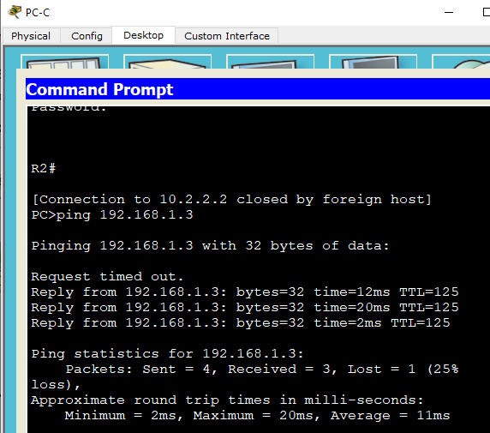
Step 2: From internal PC-C, SSH to the R2 S0/0/1 interface.
a. From the PC-C command prompt, SSH to R2 at 10.2.2.2.
ssh -l SSHadmin 10.2.2.2
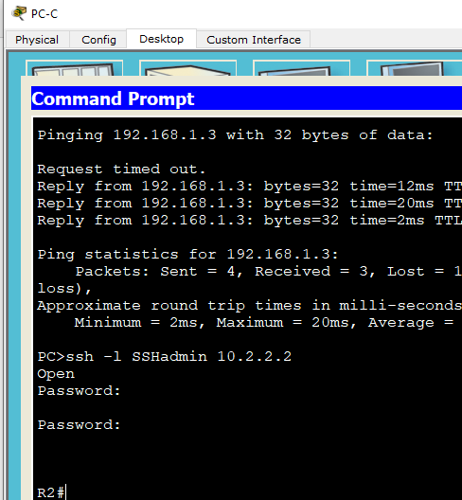

b. While the SSH session is active, issue the command show policy-map type inspect zone-pair sessions on R3 to view established sessions.
R3#show policy-map type inspect zone-pair sessions
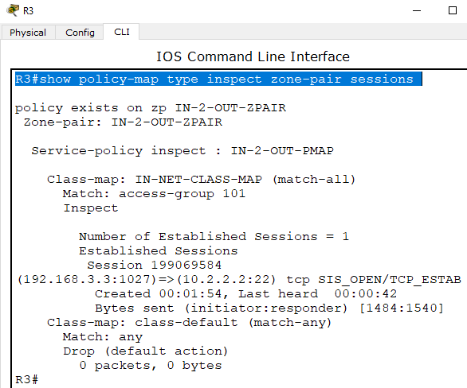

Step 3: From PC-C, exit the SSH session on R2 and close the command prompt window.
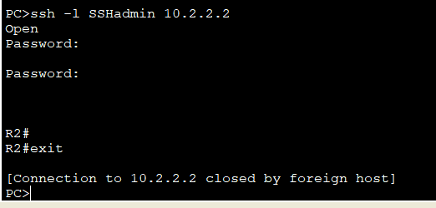

Step 4: From internal PC-C, open a web browser to the PC-A server web page.
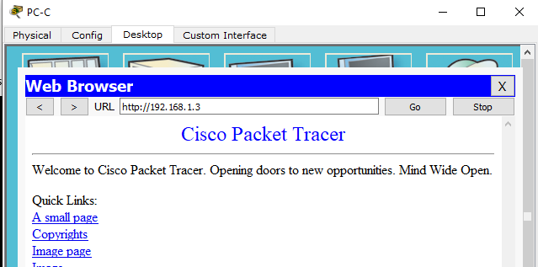
While the HTTP session is active, issue the command show policy-map type inspect zone-pair sessions on R3 to view established sessions.
R3#show policy-map type inspect zone-pair sessions
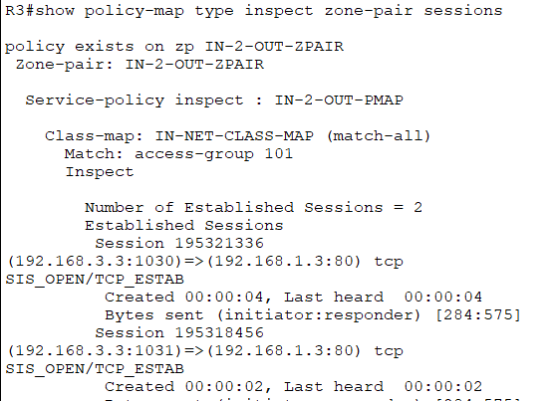

Step 5: Close the browser on PC-C.

Part 7: Test Firewall Functionality from OUT-ZONE to IN-ZONE
Step 1: From the PC-A server command prompt, ping PC-C.
From the PC-A command prompt, ping PC-C at 192.168.3.3. The ping should fail.
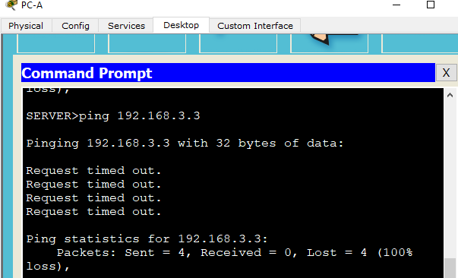
Step 2: From R2, ping PC-C.
From R2, ping PC-C at 192.168.3.3. The ping should fail.
